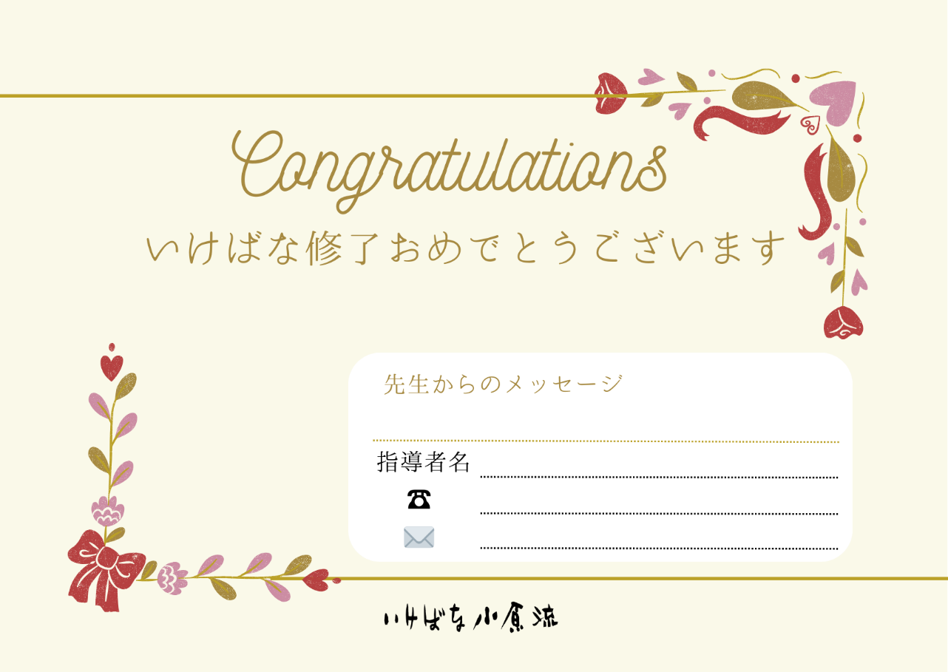

Aa

aa

aa

aa

aa