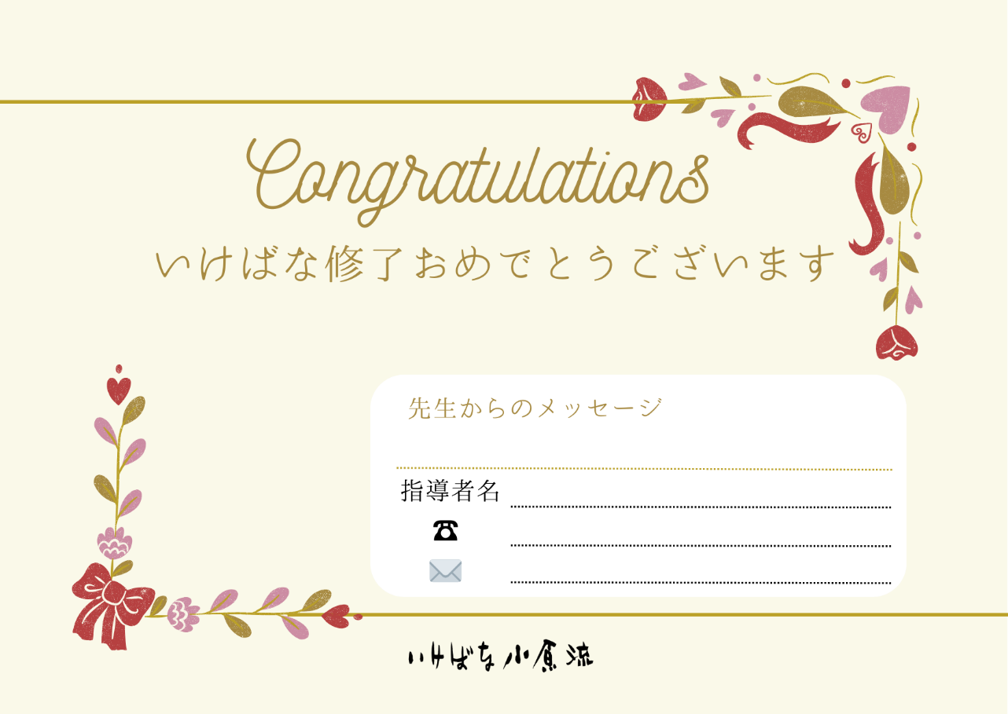



Aa

aa

aa

aa

aa

Aa

aa

aa

aa

aa

Aa

aa

aa

aa

aa

Aa

aa

aa

aa

aa